Subject | ISPyB
Document | Technical documentation
Creation | 04/06/2007
Last Update | 03/08/2007
Author

CONTENTS
Purpose 3
Use cases 4
Samples use cases 5
Create 6
Create new unassigned sample 6
Create a new sample from a container 7
View 8
View all samples 8
View unassigned samples 8
View samples for a shipment 9
View samples for a dewar 9
View samples for a container 10
View samples for a protein & crystal form 10
Edit 11
Edit a sample 11
Delete 12
Delete a sample 12
Display 13
Display all sample details 13
Unassign 14
Unassign = remove sample from container 14
Assign 14
Assign a sample to a container 14
Search 15
Search by protein acronym 15
Search by sample name 15
Export 16
Export sample list as PDF 16
Installation notes 17

FIGURES
Figure 1 Create a new unassigned sample 6
Figure 2 Create a new sample from container 7
Figure 3 View all samples 8
Figure 4 View unassigned samples 8
Figure 5 View samples for a shipment 9
Figure 6 View samples for a dewar 9
Figure 7 View samples for a container 10
Figure 8 View samples for a protein & crystal form 10
Figure 9 Edit a sample 11
Figure 10 Delete a sample 12
Figure 11 Display all sample details 13
Figure 12 Remove a sample from a container 14
Figure 13 Assign a sample to a container 14
Figure 14 Search samples by protein acronym 15
Figure 15 Search samples by sample name 15
Figure 16 Export as PDF 16

Purpose
This document explains how ISPyB application works. We will describe how both the server side and how the client web side work. All diagrams are made with the UML notation (made with Enterprise Architect software).

Technology used is java J2EE with EJBs CMP and BMP in the server side, and struts forms and actions for the web client side.

Use cases

The figure below represents the use cases to describe all of the functional aspects of ISPyB features. We will describe later how these use cases works.

There are 4 roles defined for ISPyB now:
- The standard User : any one belonging to the same proposal account. He can only manage data related to his proposal.
- The industrial user : he can manage data linked to his account, but he doesn’t have access to restricted data related to his data collections performed on site by ESRF people.
- The internal user linked to an industrial account : This user have no restriction on the data. He uses them for internal ESRF purpose (ex: invoicing, performance).
- The MXPress Administrator : He can manage all the MXPress accounts. He can launch any database updates for all the accounts.

There are a few differences between standard user, industrial user and internal user linked to an industrial user. Therefore we will described the standard user use cases, and the differences will be listed after.
We will describe in another part the use cases of the MXPress manager.

There are mainly 4 categories of use cases:

User manages his shipments
User manages his samples
User prepares the experiment
User follows the experiment : data collections an results

Samples use cases
We will detail in this chapter the different use cases dealing with samples concerning the standard user “User”.

Create

Create new unassigned sample
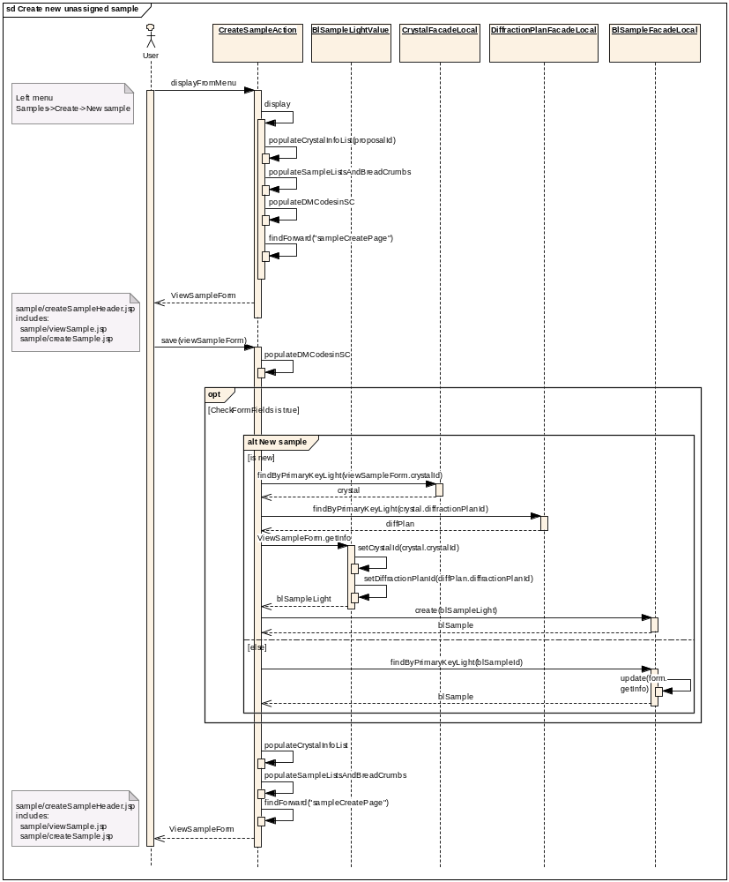
Figure 1 Create a new unassigned sample

Create a new sample from a container
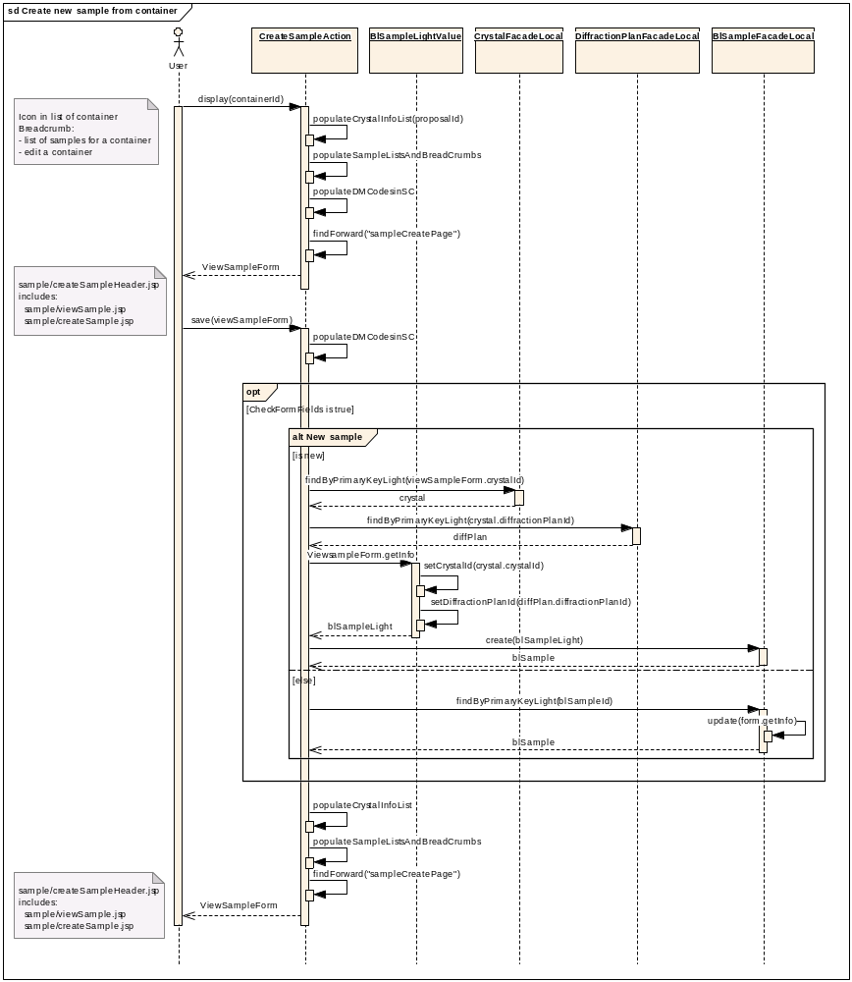
Figure 2 Create a new sample from container

View

View all samples
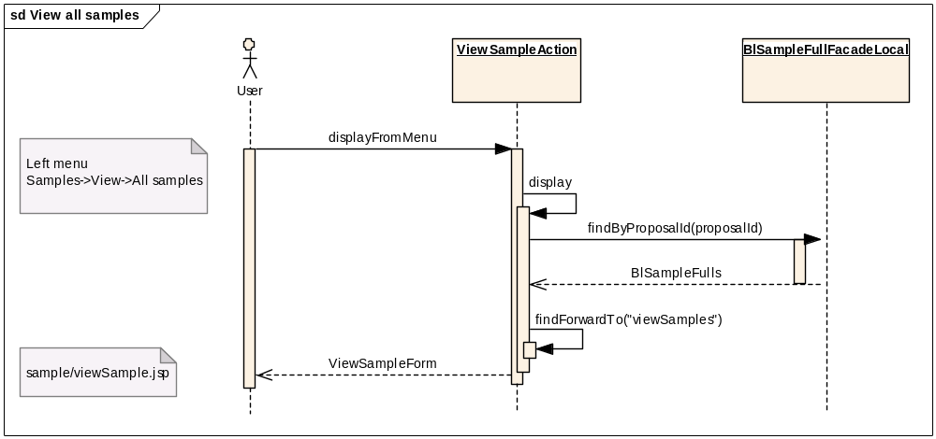
Figure 3 View all samples

View unassigned samples
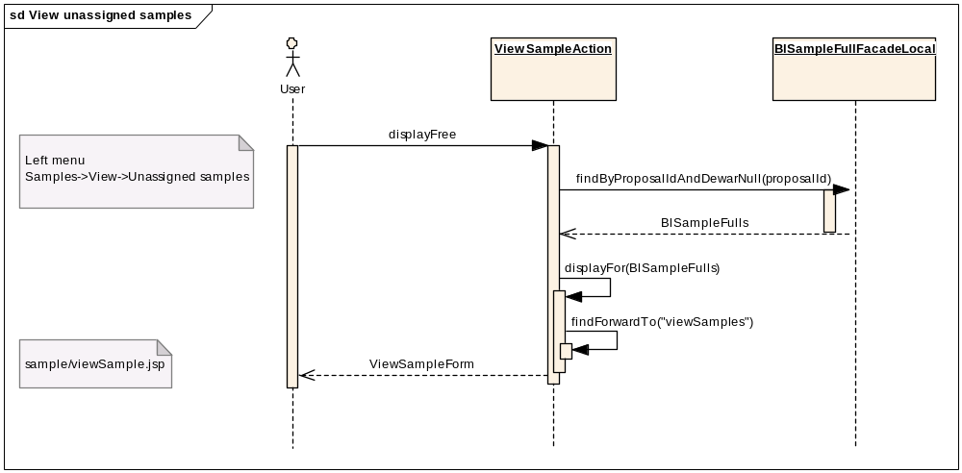
Figure 4 View unassigned samples

View samples for a shipment
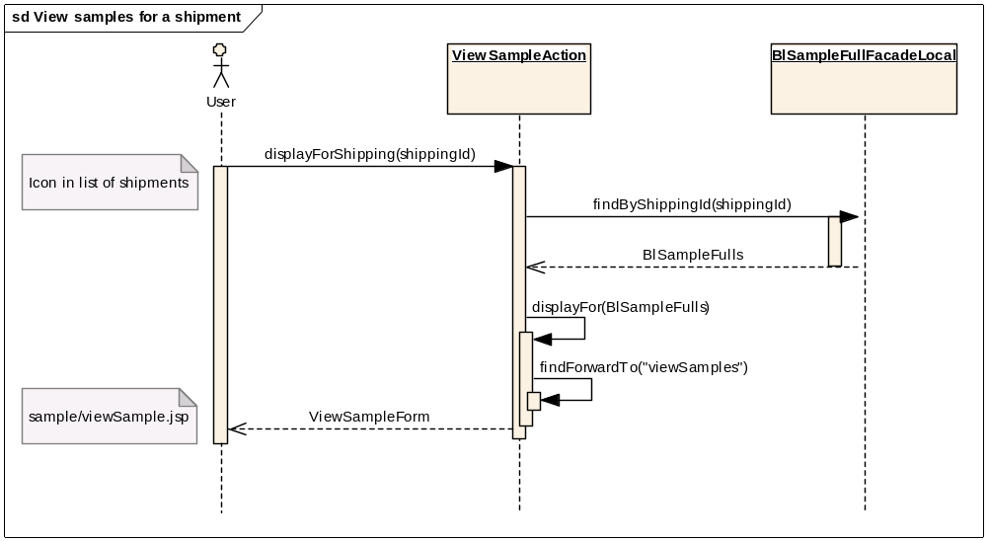
Figure 5 View samples for a shipment

View samples for a dewar
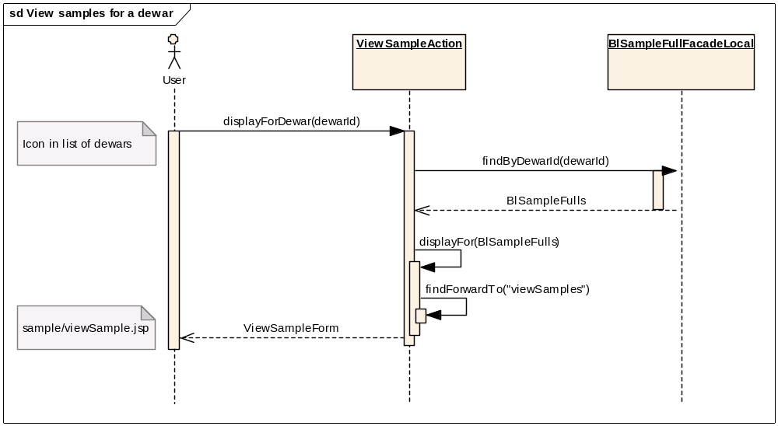
Figure 6 View samples for a dewar

View samples for a container
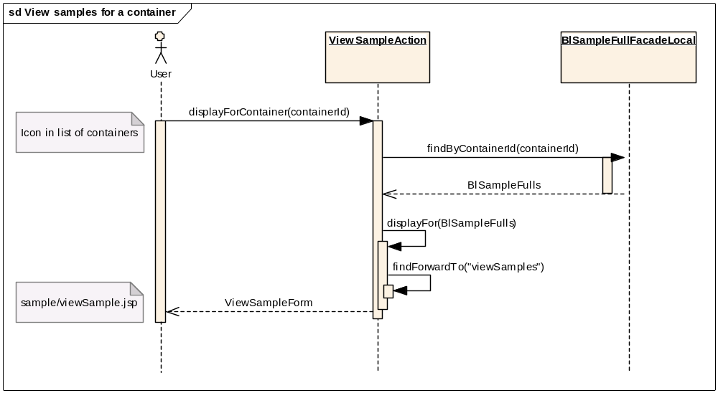
Figure 7 View samples for a container

View samples for a protein & crystal form
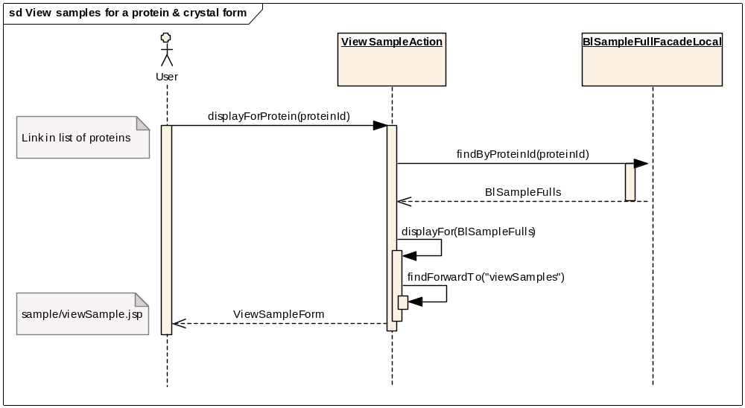
Figure 8 View samples for a protein & crystal form

Edit

Edit a sample
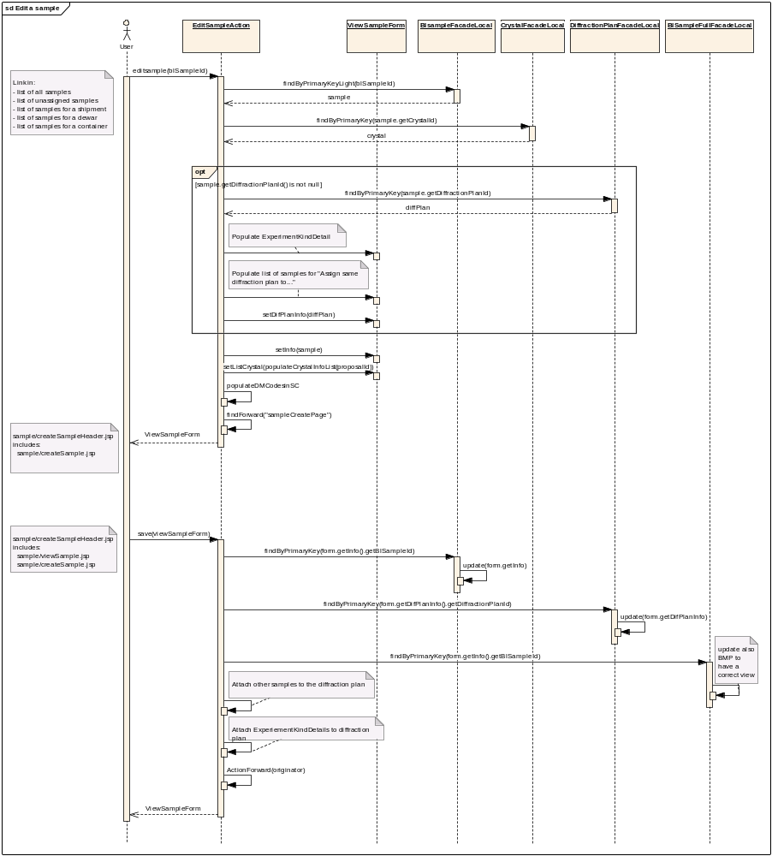
Figure 9 Edit a sample

Delete

Delete a sample
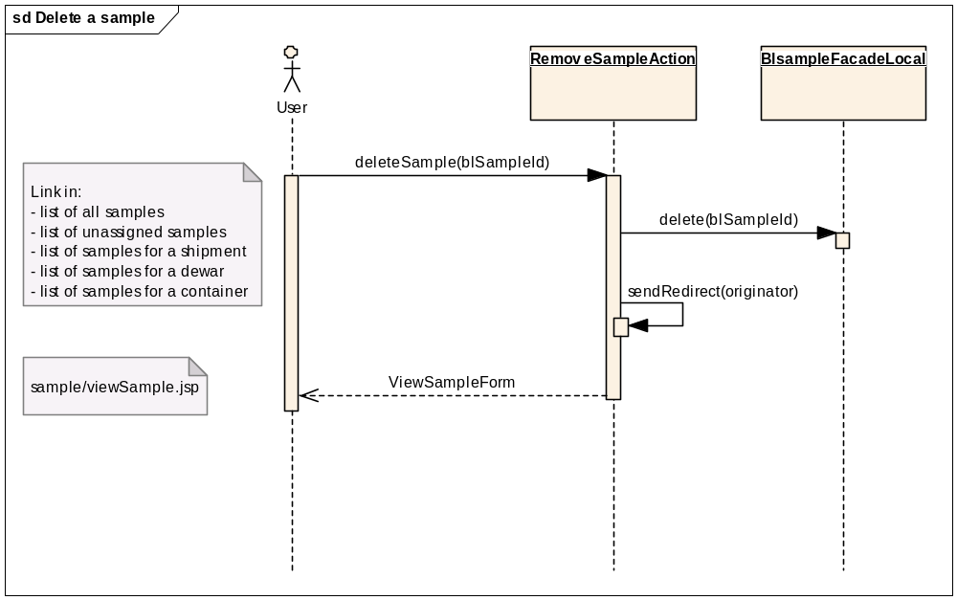
Figure 10 Delete a sample

Display

Display all sample details
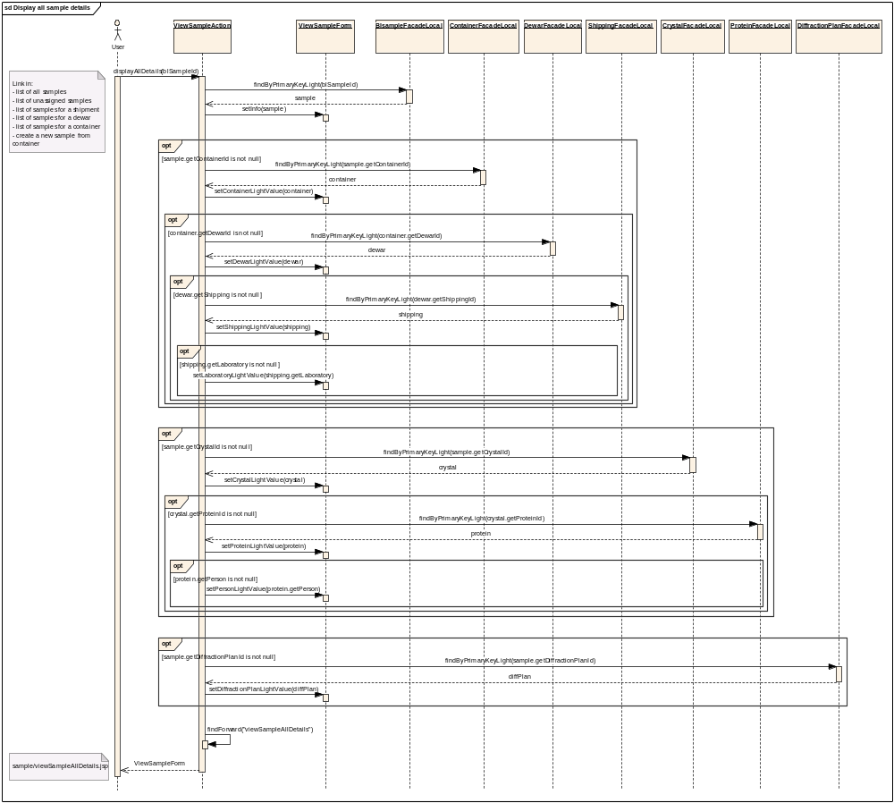
Figure 11 Display all sample details

Unassign

Unassign = remove sample from container
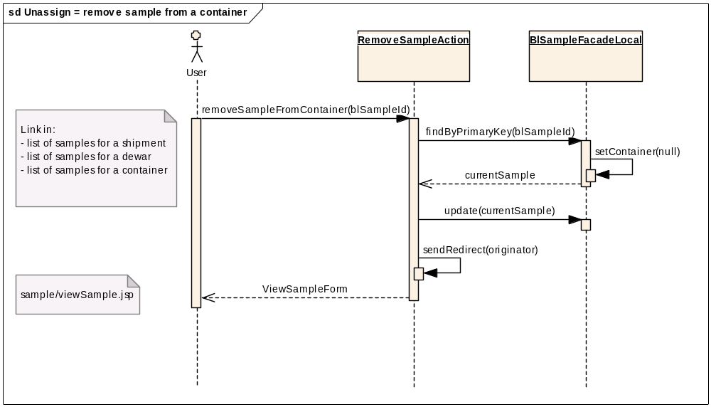
Figure 12 Remove a sample from a container

Assign

Assign a sample to a container
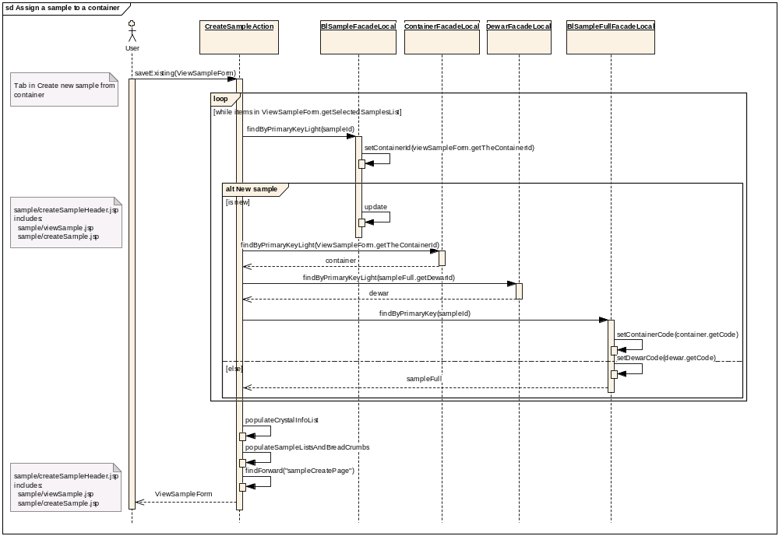
Figure 13 Assign a sample to a container

Search

Search by protein acronym
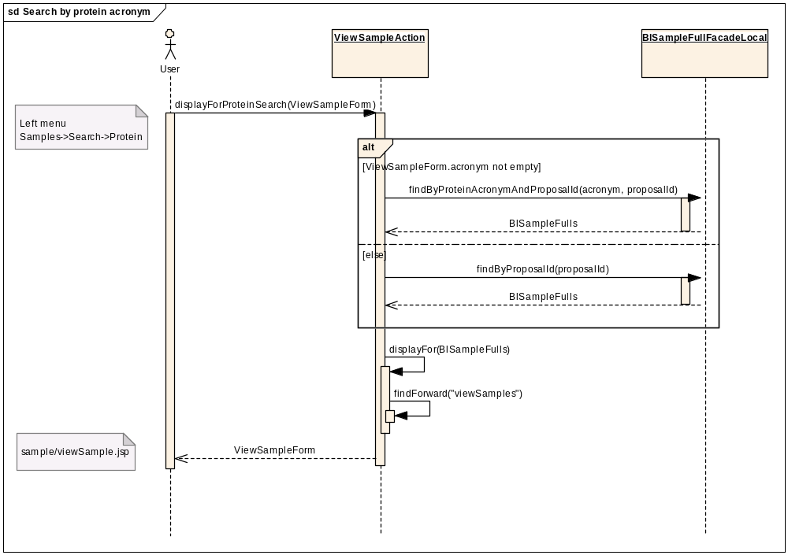
Figure 14 Search samples by protein acronym

Search by sample name
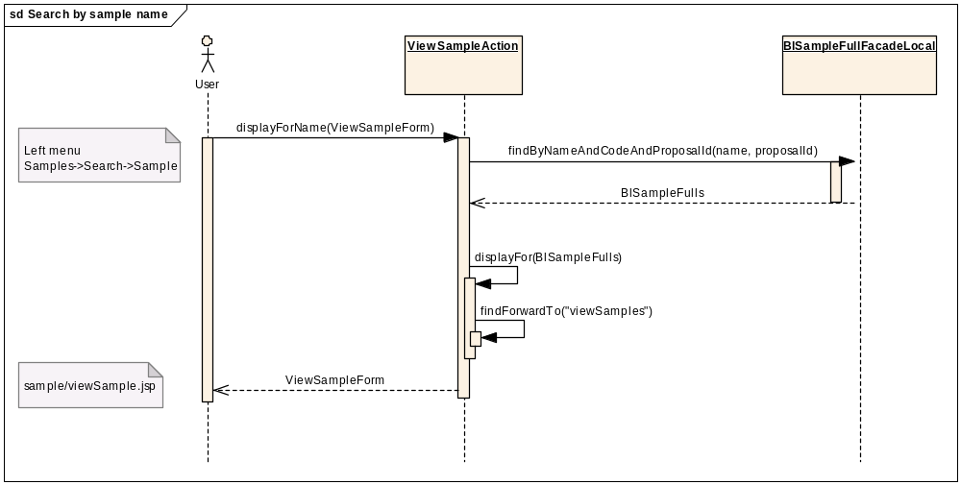
Figure 15 Search samples by sample name

Export

Export sample list as PDF
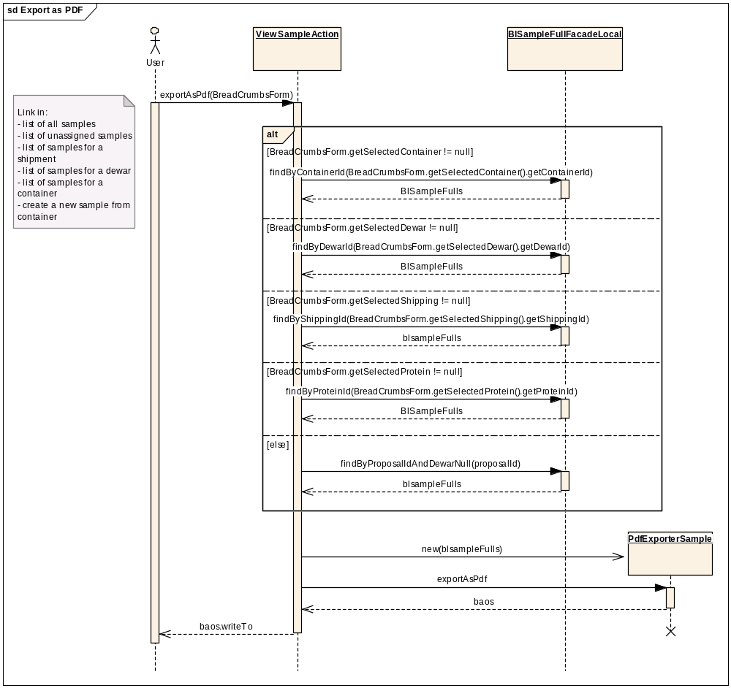
Figure 16 Export as PDF

Installation notes
The development guide is stored on CVS in the folder Documentations.
This document describes the development tools, the server configuration, the deployment functionalities…

An administrator guide, stored on CVS, helps the administrator in case of problems.

A document (ispybUseCases.xls), stored on CVS, lists all the functionalities of ISPyB.

All the sequence diagrams explaining the use cases are in ISPyB.EAP, also on CVS.

